**05-06-2025 AZURE APP SERVICE**

**What is Azure App Service?**

**Azure App Service** is a tool from Microsoft Azure that lets you create, host, and manage websites and web apps **without worrying about the underlying hardware or servers**.

Think of it like this:  
You want to build a website. Instead of buying a server, setting it up, and managing it, you just upload your website to Azure App Service, and it **does all the hard work** for you — like running it, keeping it online, and scaling it if many people visit your site.

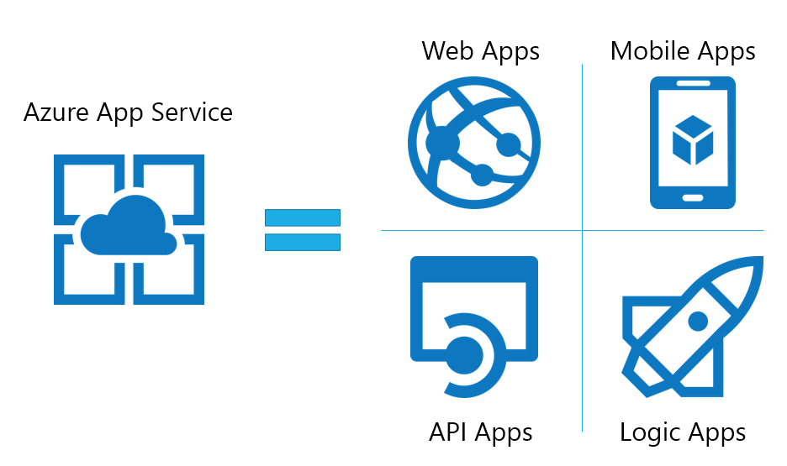

**Why Use Azure App Service?**

| **Feature** | **Simple Explanation** |
| --- | --- |
| **Supports many languages** | You can use Java, Python, PHP, .NET, Node.js, etc. |
| **Auto updates** | Microsoft keeps your app running safely and smoothly by updating the platform. |
| **Scales automatically** | Your app will handle more users automatically if needed. |
| **Secure** | It supports login features like Google, Facebook, Microsoft accounts. |
| **Easy deployment** | You can connect GitHub or Azure DevOps to automatically upload your changes. |
| **Mobile & API support** | You can also use it to build APIs and mobile app backends. |
| **Staging slots** | You can test a new version of your app before making it live. |

**Types of Apps You Can Host**

1. **Web Apps** – Regular websites like blogs or shopping sites.
2. **API Apps** – Apps that provide data to other apps (e.g., weather API).
3. **Mobile Apps (backend)** – A backend for mobile applications.
4. **Containers** – Run Docker containers using Linux or Windows

**Pricing Plans (Simplified)**

| Plan | Best For | Description |
| --- | --- | --- |
| Free | Students, learning | Basic testing, no custom domain |
| Shared | Small apps | Low cost, limited resources |
| Basic | Startup websites | More power, custom domains |
| Standard | Business apps | Daily apps with many users |
| Premium | High-traffic sites | Fast, secure, and large capacity |
| Isolated | Large companies | Highest security and performance (private network) |

**Security Features**

* HTTPS by default (secure browsing)
* Support for login with Microsoft, Google, Facebook, Twitter
* Protects apps from DDoS (Distributed Denial of Service) attacks
* Connects securely to other Azure services like databases

**Real-Life Examples**

| **Example** | **Description** |
| --- | --- |
| Online Store | You build a store with HTML + CSS + PHP and upload it to App Service. Azure keeps it running 24/7. |
| Mobile App Backend | Your mobile app needs a database and API. You build the backend and host it on App Service. |
| Blog | You build a personal blog in Python and deploy it using GitHub and Azure App Service. |

**How It Works (Simple Steps):**

1. Create **App Service** in Azure.

2. Choose **the runtime** (like Java, Python, Node.js).

3. **Upload your app code** (or connect GitHub).

4. **Test and go live!**

5. **Monitor and scale** when needed.

**Architecture Overview :**

